**Dynamic Routing**

Dynamic routing is a method of exchanging routing information between routers in a network, so that the routers can automatically learn about network topology changes and update their routing tables accordingly. Dynamic routing protocols allow routers to communicate with each other and to share information about the networks they are connected to, the available routes to destination networks, and other network topology details.

Dynamic routing protocols can be classified into two main categories: distance vector and link-state. Distance vector protocols, such as RIP, use a simple metric (such as hop count) to determine the best path to a destination network. Link-state protocols, such as OSPF and IS-IS, use more sophisticated metrics that take into account factors such as bandwidth, delay, and reliability.

**Types of Dynamic Routing:**

1. RIP Routing
2. OSPF Routing
3. BGP Routing

**OSPF ROUTING**

**Aim:**

To aid in the comprehension and use OSPF as dynamic routing idea in computer networking for network managers or students. Instead, depending on static routing technologies, OSPF dynamic routing simulates and test real-world network scenarios in a controlled environment.

**Software Required:**

CISCO Packet Tracer

**Introduction:**

OSPF (Open Shortest Path First) is a popular Interior Gateway Protocol (IGP) used for routing within an autonomous system (AS) in a large enterprise or service provider network. OSPF is a link-state protocol that builds a complete topology map of the network by exchanging information about network links and their states with other OSPF routers in the network. This enables OSPF to calculate the shortest path to a destination network using the Dijkstra algorithm and to dynamically adapt to changes in the network topology.

**Steps Involved for OSPF Dynamic Routing.**

1.Set up a network with some end-devices and Switches and Routers. I have set up 2 PCs and 2 switches and 4 Routers.

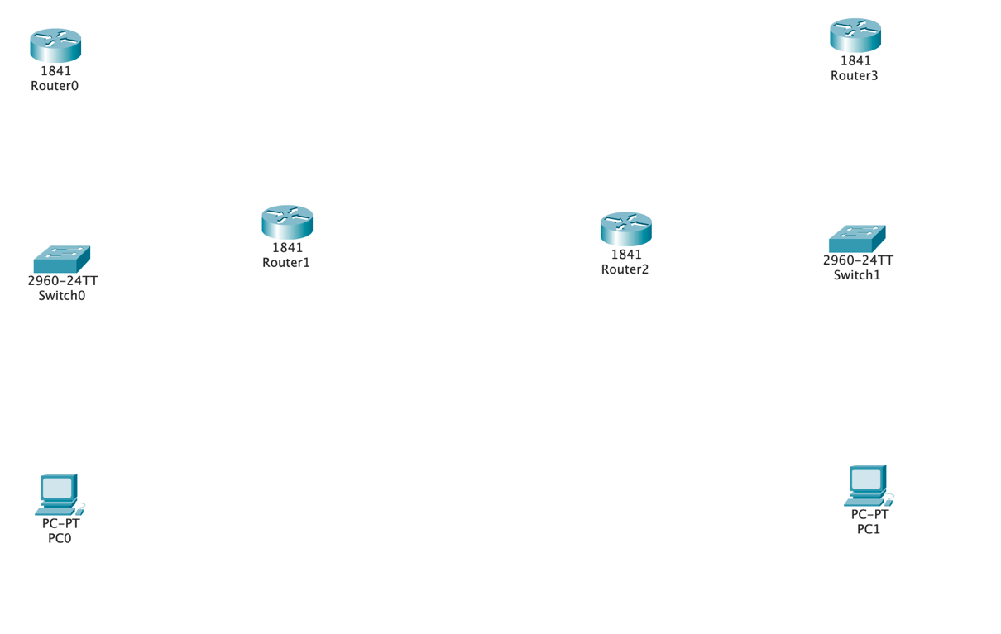

2.Connect Devices to Each other Using Thunderbolt, copper straight- through and serial DTE.

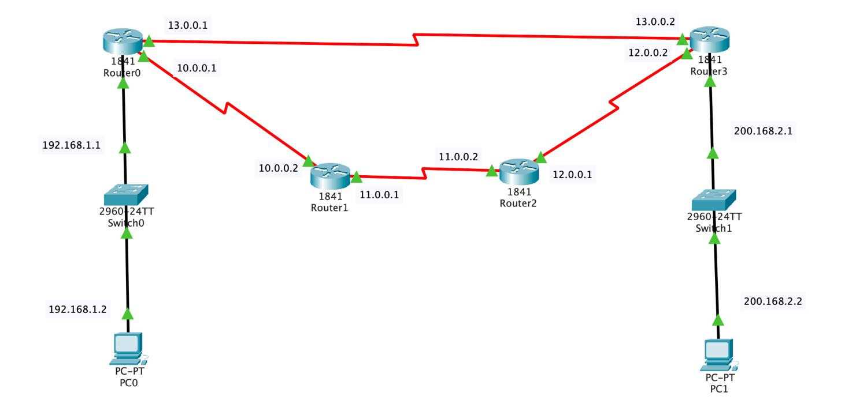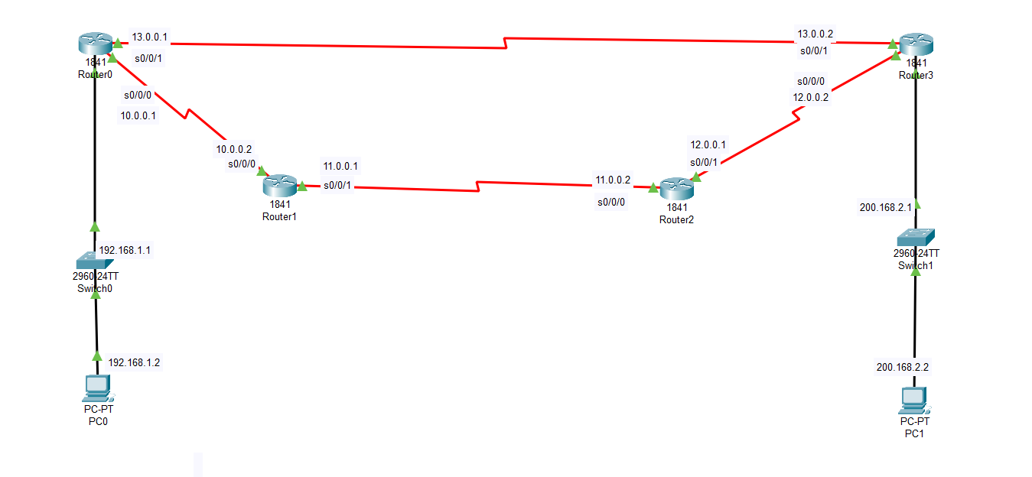

3.Provide Ip address and Default Gateway to PC’s.

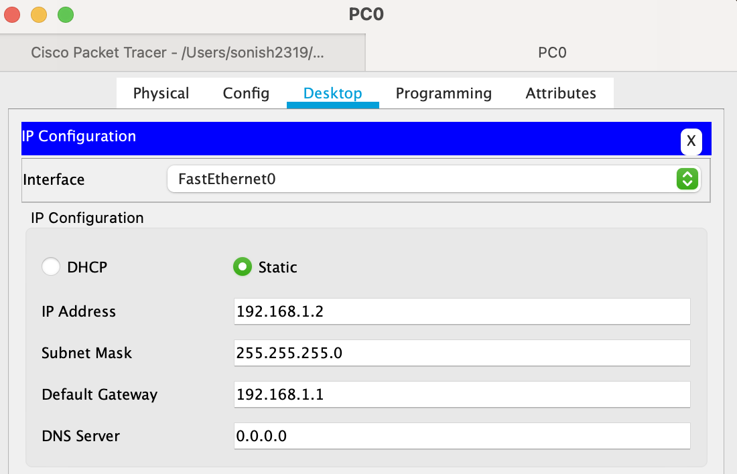

**4.Configure IP of all routers.**

* Router 0 IP Configurations

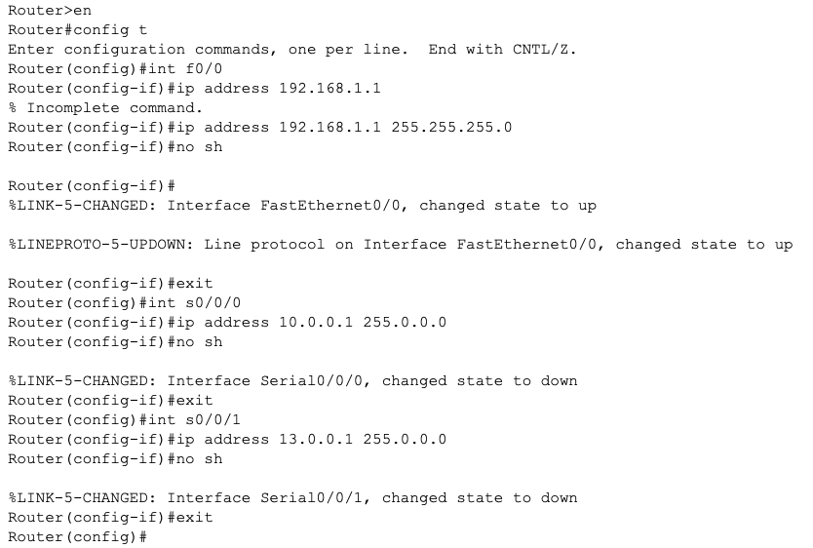

Router 1 IP Configurations

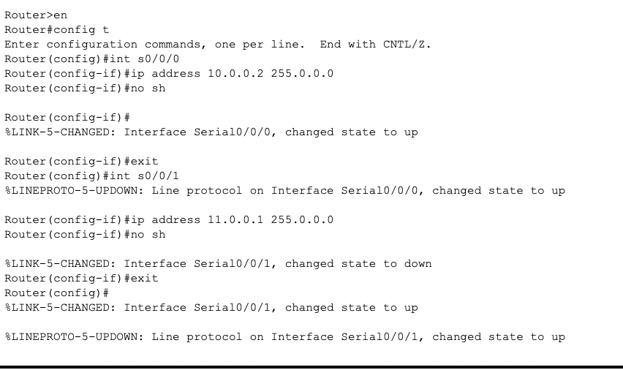

* Router 2 IP Configurations

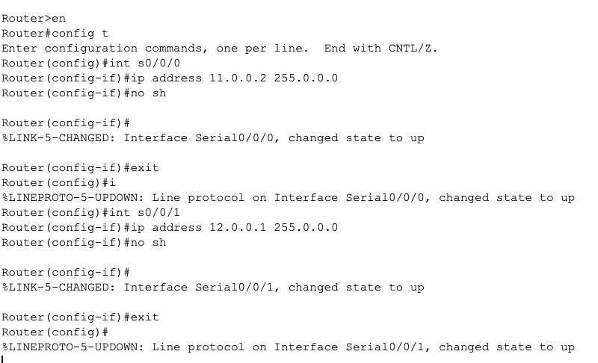

* Router 3 IP Configurations

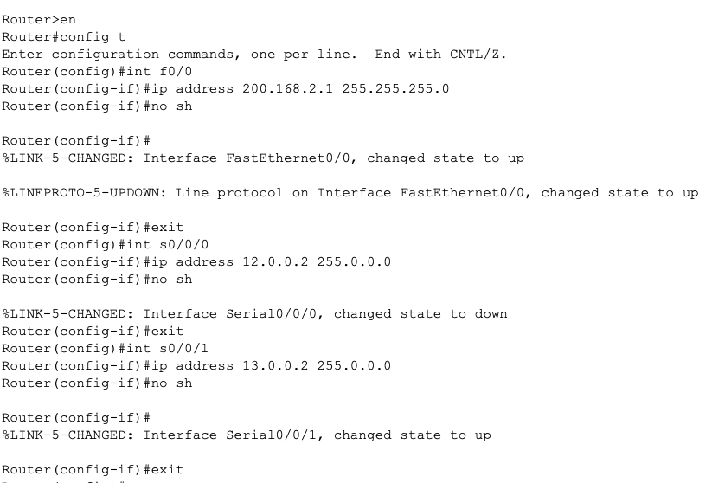

**5.Configuring the Dynamic routes**

* OSPF Route of ROUTER 0

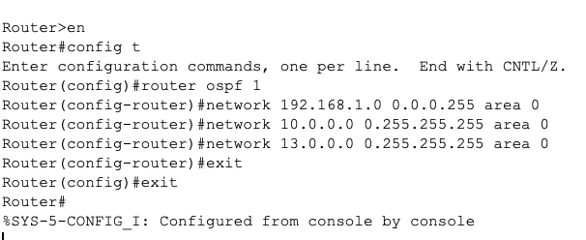

* OSPF Route of ROUTER 1

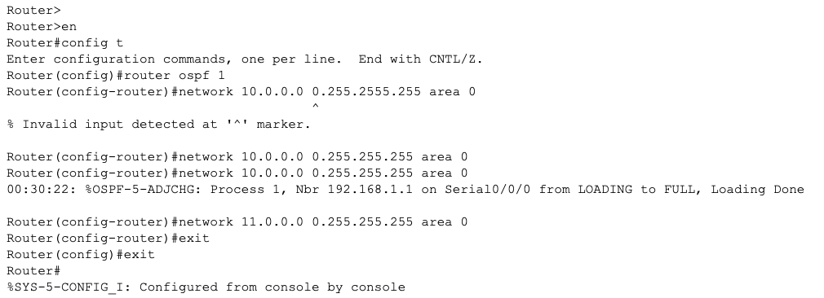

OSPF Route of ROUTER 2

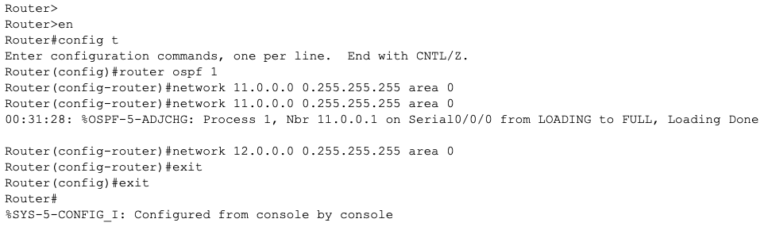

* OSPF Route of ROUTER 3

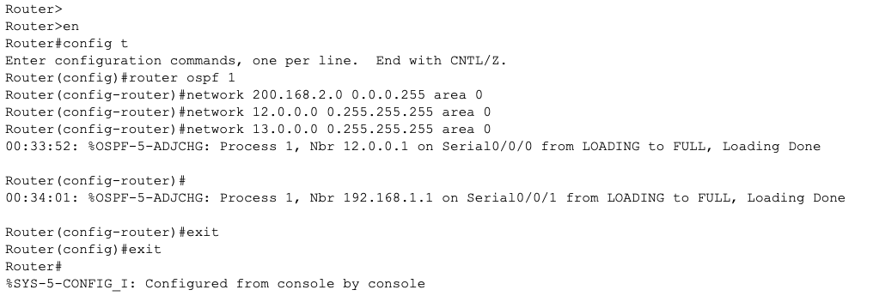

**Testing:**

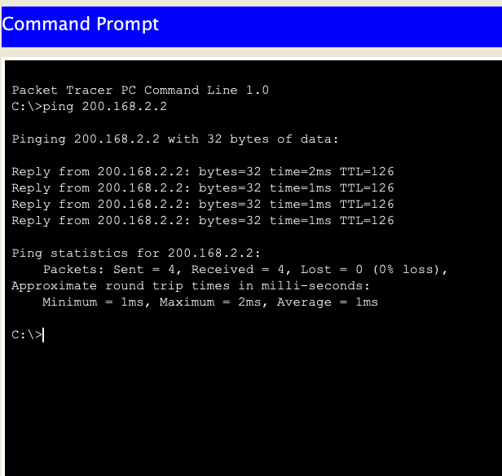

Figure: Ping from one to another computer

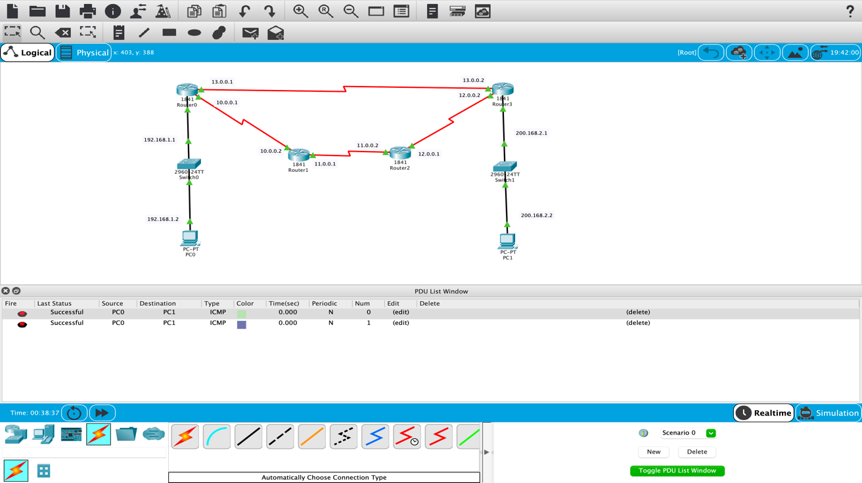

Figure: Message Transfer from one to another computer